Empowering Efficient Data De-duplication with User Centric Security Control in Cloud

G.Indiravathi¹ Dr.B.GeethaVani² R.Charishma³ K.Charithasree⁴

M.Ajay⁵ S.Kowshik Reddy⁶

¹Assistant Professor, ² Professor, ³⁴⁵⁶UG Student, ¹²³⁴⁵⁶Department of Computer Science and Engineering, ¹²³⁴⁵⁶Siddharth Institute Of Engineering & Technology, Tirupathi,

Andhra Pradesh, India,

Email: ¹remala.indu@gmail.com , ²bgeethavani1269@gmail.com, ³cheryracr@gmail.com , ⁴charithasree1918@gmail.com , ⁵mallelaajay2000@gmail.com , ⁶sadulakowshikreddy@gmail.com

ABSTRACT:
The most popular cloud computing technology these days is clouding up, which is done across a vast communication network like the internet and offers enormous space for storing in all sectors, including administrative units, private firms, etc., in addition to saving personal information on the cloud. However, the most significant disadvantage of the cloud is the enormous amount of storage space required, as well as the fact that duplicate copies of knowledge are stored there. A number of approaches are used to get rid of redundant copies of the continuing information. One essential technique to eliminate duplicate copies of continuous data is information DE-duplication, which is a specialized data compression method that has been widely used in cloud storage to reduce the amount of space needed for storing and saving measurement systems. Confluent encryption is a technology that encrypts data before it is outsourced, protecting its confidentiality on cloud computing. Theme of secret sharing is applied in the envisioned system. The units of measurement in such files are separated into different blocks called shares, which are stored on various different types of nodes. Through victimization recovery techniques, different shares are combined into a line. This implies victimization and offers data protection, privacy, and accountability.

Keywords: Digital Signature, Honey words. Sugar Words, hash code.

INTRODUCTION

The information revolution has resulted in a significant proliferation of data, and many individuals and organizations are already having serious difficulties managing this enormous number of data and figuring out how to store and secure it [1]. Global information is defined by the International Data Corporation (IDC) as data generated, recorded, or transcribed using widely dispersed digital resources. According to IDC predictions [1], the amount of data in the world will increase from 33 zettabytes (ZB) in 2018 to over 175 ZB by 2025.
Almost three-quarters of the current digital data are duplicates, according to a research done on the global data set by several major corporations, including Google, IBM, Microsoft, Intel, and Motorola [2]. Organizations, IT firms, and industries must so urgently store vast amounts of data securely and have rapid access to it for processing and retrieval. The process of backup and maintenance is one of the most difficult jobs in big data because of the volume of data involved. These procedures are expensive and regarded as hurdles in this field [3].
As a result, keeping and organizing such enormous volumes of digital data presents a big difficulty [4]. Therefore, one of the best ways to address these issues is to use the DE-duplication technique, which keeps duplicate data off of hard drives [5]. The most popular technique for lowering the amount of space needed for primary file systems and backup data is data de-duplication [6]. There are four main steps in the data de-duplication system: chunking, fingerprinting, indexing, and data writing.
Chunking, the process of dividing large volumes of incoming data into manageable portions or chunks, is the initial stage that is thought to be a bottleneck in the removal of redundant data [7]. There are two methods for achieving chunk-level de-duplication: variable size chunking (VSC) and fixed-size chunking (FSC) [8]. The contents of the file split into equal-sized pieces in FSC. The VSC breaks the file into chunks that do not have to be of equal sizes and does away with the boundary shifting problem that plagues the FSC, which has low de-duplication efficiency. Although the VSC approach takes longer to process and requires more processing, it offers a higher percentage of de-duplication [9].
The second step in the data de-duplication process is fingerprinting, in which a unique value is assigned to each chunk. In this step of the data de-duplication process, hash algorithms like the Secure Hashing Algorithm SHA-1 or the Message-Digest Algorithm MD5 are commonly utilized to create a digest, or fingerprint, for every chunk. In order to identify the duplicate chunks, the fingerprint values of the newly added chunks are compared with the fingerprint values that were previously saved at the third stage of indexing. Chunking fingerprints are used in indexing to locate and eliminate duplicate chunks that may be recognized.
If the two portions' fingerprints do match, they are regarded as being identical. Writing, which creates a distinct copy of the data on the hard drive, is the fourth step in the data de-duplication process. A hash table is used to hold the unique chunks that are not duplicates and do not have identical fingerprints [10]. This paper investigates various classifications to eliminate redundant data: time-based (prior to or subsequent to data being stored on disc), granularity-based (file-level or chunk-level de-duplication), based on storage location de-duplication, side-based de-duplication, and implementation-based de-duplication.
A summary of the history of data De-duplication technology, the benefits and drawbacks of each algorithm, the technological approaches employed, and an analysis of the issues and difficulties facing data De-duplication-based storage systems are also included. New algorithms and techniques for enhancing de-duplication have been presented in a number of recent papers and survey contributions in the subject. Furthermore, certain researches concentrate on a particular facet of de-duplication, like cloud storage and chunking or indexing systems. The survey's other portions were organized as follows.
Section 2 lists the main advantages and disadvantages of data deduplication. Section 3 includes a few of the most current studies that looked into different De-duplication techniques. Several De-duplication techniques are covered in great detail in Section 4. The main steps in data de-duplication are covered in great detail in Section 5. In Section 6, the survey summary is finally displayed.

II. DE-DUPLICATION

One of the most crucial methods for getting rid of redundant data is data de-duplication [1]. Thanks to this strategy, businesses can save a significant amount of money on bandwidth and storage. Because it eliminates the need for extra storage devices, it is advantageous for cloud services [2]. Reducing the amount of data that is duplicated can help with storage issues. Data chunking, fingerprinting, indexing, and writing are the four primary processes involved in deleting duplicate data [3].
"Fig. 1" presents a broad overview of the four primary phases of data deduplication. The benefits of data de-duplication are numerous and include: 1. Increased network efficiency. 2. There is little room needed for storage. 3. There is a decrease in storage costs. 4. The effectiveness of storage is improved. Decreased upload speed [4]. However, there are a number of drawbacks to the De-duplication method, which are as follows:
1. some more resources are needed for the duplicate data elimination procedure.
2. Inconsistencies in hash functions can lead to a loss of accuracy and consistency in data.
3. Privacy and Security.
4. Data duplication reduction impacts storage system availability

- Types of De-duplication Techniques

It is possible to eliminate duplicate data from the data storage in a few different ways. However, most firms use de-duplication strategies to solve and mitigate the duplication issue [7]. The many techniques for eliminating unnecessary data are shown in "Fig. 2" [2]: • based on Level of Detail Prediction There are three different kinds of de-duplication: side-based, time-based, and implementation-based.

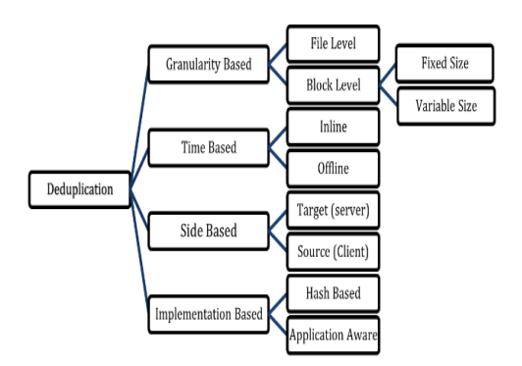
Figure. . Types of de-duplication approaches

Based on Granularity:
There are two categories of de-duplication based on the first requirement, which are as follows:
1) De-duplication at the file level: Instead of handling the full file as several chunks, file-level de-duplication handles it as a single piece [9]. This method finds and removes duplicate files by creating a single hash value for the entire file and comparing it to the hash values of the previously stored files [10]. The internal contents of the file are unaffected by this procedure. For instance, two files are regarded as separate files if they are saved with the same internal content but different names.
This method is simple, quick, and little processing resource. This method is also known as single-instance storage [8]. The de-duplication method with file-level de-duplication is displayed in "Fig. 2".

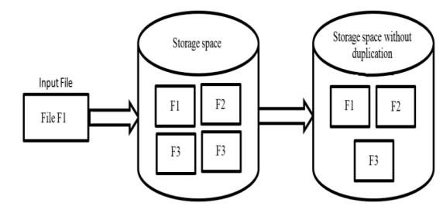

Figure. 2. File-level de-duplication

Chunk-level de-duplication: This method divides the file into multiple little blocks, referred to as chunks. In data de-duplication, each chunk's unique copy is stored and the file is searched for duplicate chunks. There are two methods for de-duplicating portions in files [23]. Files may be partitioned into chunks of variable length, or pieces with varying sizes, or into chunks of set length, or chunks of the same size [25]. Compared to file-level deduplication, chunk-level data deduplication is significantly more efficient [26]. The Definable Content Depending on the content of the data stream, the Chunking CDC algorithm divides the data stream into chunks of different sizes; when the local content is unchanged, the chunk limits remain unchanged [27]. Fixed-Size Chunk (a) De-duplication: A typical hash algorithm is used to identify identical chunks once the file is divided into fixed-size parts [28]. Chunk sizes can vary from 8 KB to 64 KB [29]. The primary disadvantage of this approach is that any alteration, no matter how small, to the chunk causes the drive's collection of subsequent chunks to be rewritten.
For instance, all boundaries of the current chunk established using FSC are altered if a single byte is entered at the beginning of this data stream. This reduces redundant selection and, consequently, de-duplication. Put differently, it experiences an issue known as border shifting. However, this method is often used with a low remove data redundancy ratio.
b) Variable size chunk de-duplication: This sort of partition divides a file into chunks based on the internal content of the file [30]. Using a technique called Content-Defined Chunking CDC, the file is divided into chunks of different sizes [23].The size of the boundaries established by this technique is variable and is dependent on a number of variables that may alter in response to modifications or deletions made to a file's content [31]. This method becomes more resistant to adding or removing new data because of the modification in the boundaries it adopts [30]. Nevertheless, in order to carry out a thorough file scan and identify the boundaries of each chunk, this technique requires additional system resources, such as the CPU [23]. 2) Granularity-based Benefits and Drawbacks: Granularity classification classifies redundant data based on its Granularity, which describes how this affects various storage methods, how these methods are used in such systems, and how those different methods affect resource consumption, performance, and deduplication efficiency. Granularity-based data classification has several limitations, the most significant of which being the restricted capacity of conventional hash storage systems to minimize data redundancy.

Based on Time deduplication:
There are two approaches in this approach [23]. 1) Inline deduplication: This technique reduces storage capacity by removing redundant data either during or prior to writing it to the hard drive [23]. Because it only processes the data once, this approach is strong and adaptable [8]. When data is transferred from the data source/client to the target/server, inline deduplication can be performed on the client-side [10]. But because the inline deduplication method only analyses the incoming raw chunks and is unaware of other chunks, it can only employ a fixed length chunk [17]. The primary disadvantage of this method is that it is highly dependent on network efficiency. However, while the computation time is considerable, this method requires less storage capacity [32].The deduplication method using Inline Deduplication of Data is displayed in "Fig. 5". Inline Deduplication of Data, Figure 5 [24]. 2) After data is first written to the storage medium, duplicate data is located and eliminated by post-process deduplication [23]. Post-process deduplication may be advantageous at both the file and sub-file levels [17]. Because this method requires less calculations than the inline approach [33], its performance is better. This method's main disadvantage is that it costs more than the inline method because it needs an additional disc cache [32]. "Fig. 6" illustrates the data post-process deduplication.
Figure 6. Data Duplication after Processing [24]. 3) The benefits and drawbacks of time classification: All deduplication solutions in the time classification rely on the timing of the process, namely whether it happens during or after the storage operation. Post-process deduplication takes place after data has been written to disc, as opposed to inline deduplication, which happens during data flow.
Due to the postponement of the hash calculation, post-process deduplication performs faster on storage than inline deduplication. Inline deduplication requires less storage and network traffic than post-process deduplication, which is more comparable. Compared to post-process deduplication, inline deduplication has a lower storage throughput. Post-process deduplication necessitates temporary storage space, whereas inline does not.

Based on Side:
There are two techniques in this approach: target deduplication and source/client deduplication.
1) Source/Client deduplication: This method eliminates redundant data at the source prior to transmission [33]. Prior to data transfer to the backup device, data removal occurs on the client/source side [32]. The fact that this kind of data elimination doesn't need as much bandwidth as target deduplication is one of its key characteristics.
Consequently, source/client deduplication offers two primary benefits: it maintains unique data and requires less capacity for data transmission [32]. This method's drawback is that it uses all of the client's resources to de-duplicate data [24]. The drawback of this approach is that, in order to complete the deduplication procedures, the client CPU is burdened with up to 15% overhead. Furthermore, processing times will rise in the event that massive volumes of data need to be handled, which will cause the source side servers to lag [20].
2) Target deduplication: Since all comparable data is fully moved to the backup server, the duplication procedure takes place at the backup server's side [24]. Because target data contains all of the data in its complete duplicate, target data deduplication is a quick and simple server-side process [9]. Due to the potential for duplicating data, this approach has the drawback of requiring greater bandwidth for data transmission [24].
3) The benefits and drawbacks of side classification less bandwidth is needed for source deduplication than for target-based deduplication. The resources required for target-based deduplication are less than those required for source-based deduplication. When using a source rather than a target, the client's processing overhead is higher. Consequently, compared to target-based, the source-based technique is slower. D. Predicted on Execution There are two techniques in this principle in this approach [32].
1) Hash-based deduplication: This technique is used to determine whether two documents or two portions of a document are identical [32]. The data is first hashed in terms of content. Subsequently, the generated signatures of the two pieces are compared to determine whether or not they are redundant [24]. The two entities are rejected as being too similar if the produced signatures match. If not, the hard drive stores it. Lastly, it may determine a data hash value using any of the established hashing algorithms, such as SHA-1, SHA-256, SHA-512, and MD5 [32].
2) Content-aware deduplication, also known as application-aware deduplication: In the deduplication application, data is handled as an object when employing this technique [24]. The comparison procedure is carried out at the object level. It only preserves the bytes that have changed between the two portions after identifying identical parts [8]. At the byte level, redundant data is eliminated [24]. Only bytes that have changed or are unique are stored using the content-aware method, which searches for comparable fragments or bytes [32]. For instance, knowing the boundaries of a file can be useful in data deduplication if a backup stream is being performed on it and those bounds are known [34].
3) Benefits and drawbacks of the implementation classification: To examine and distinguish between various systems according to efficiency and speed, this classification calls for implementing content-based deduplication or application-aware systems, which address the shortcomings of earlier classifications. Because content-aware-based deduplication simply processes and compares data in items of the same type, rather than comparing with all objects, it is faster than content-based deduplication. The latter is more effective than the former in comparison.
Table II presents a comparison of several data deduplication approaches. V. Stages of Deduplication Four steps can be used to sum up the essential steps involved in data deduplication: writing, chunking, fingerprinting, and indexing. These phases and the methods applied in each are covered in full in this research [18].
Algorithms for Chunking Data chunking is the process of dividing files or data streams into several segments of either constant or variable length [12]. The task of splitting files into chunks is handled by a variety of chunking algorithms. The following are the primary benefits and drawbacks of these algorithms, which will be examined and discussed in this section:

1) Rabin Fingerprint Algorithm:
Repetitive data in deduplication systems and network traffic was removed using the Rabin fingerprint [35], which is based on the CDC method [36]. The Rabin technique sets minimum and maximum limits on the chunk sizes to avoid extremely short or very long output from the algorithm.
While too-long chunks reduce deduplication efficiency, tiny chunks include more fingerprints and require more space to store and process, making them less cost-effective [37]. Two primary issues plague Rabin's approach [38]: the first is the lengthy computation of each piece's fingerprint [37], and the second is the substantial variation in chunk size, which lowers the effectiveness of eliminating redundant data.

2) Two Divisors (TD) Algorithm:
The foundation of the TD [39] algorithm is the use of a secondary divisor to identify the breakpoints for splitting big pieces. Given that it is utilized to solve the boundary shift issue brought on by the BFS algorithm, it has a strong likelihood of obtaining the duplicate chunks [39]. The first steps in the TD technique are to examine the stream file, look for the breakpoint, and make a fingerprint for every chunk [34]. Next, it verifies that both divisors' fingerprints match. If the first divider detects a match in the fingerprint before the threshold value, it will be a breakpoint.
The second divisor is employed if, within a given threshold value, the first divisor is unable to reach these breakpoints. It looks for a breakpoint using the secondary divider [39].

3) TTTD (Two Thresholds, Two Divisors) Algorithm:
Combining the TD method plus the SCM (Small Chunk Merge) technique results in the TTTD algorithm [39]. The Rabin algorithm's effectiveness in eliminating redundant data is enhanced by the TTTD method. To lessen the variance in the chunk size, which has a high likelihood of locating the breakpoints, the TTTD method offered an extra backup divisor [27].Four parameters are used by the TTT algorithm to find the breakpoints: D (Primary Divisor), Tmax (Maximum Threshold), Tmin (Minimum Threshold), and D (Primary Divisor). In order to account for fluctuation in chunk size, the minimum and maximum threshold values should be established such that the second divisor is half of the base divisor [40].

4) MAXP:
The chunk size variance problem of the Rabin algorithm is resolved by the CDC algorithm MAXP [39], which looks for local extreme values inside a symmetric fixed-size window. It is also advised to use MAXP to get rid of network redundancy [34]. By shifting a fixed-size symmetric window byte by byte over the byte stream, the MAXP determines if the value of a byte at the centre of the window is the maximum value. The input stream is divided using the extreme points as a cut point. The chunking speed [4] is greatly decreased by the MAXP approach [44], which locates local extreme values by rechecking part of the previously compared bytes.

5) Bimodal:
The bimodal approach combines chunks of varied It is an enhanced iteration of the CDC method with average sizes [26]. The bimodal method dynamically splits the expected chunk's size into its component halves. It functions to divide the data stream into big chunks and smaller chunks for non-duplicate portions. Two techniques for removing duplication in big chunks serve as the foundation for this algorithm [45].
In the first method, the data stream is divided into huge chunks. Then, the data near the boundaries of the chunks containing the changing area are divided into smaller chunks once the sections of the new chunk's content have been identified. In order to tackle the boundary shift problem, the second technique combines the little pieces from the first way into a large one using a flexible algorithm [20].

6) MCDC (Multimodal Content Defined Chunking):
In order to optimize the effectiveness of Bimodal Content-Defined Chunking, the MCDC algorithm [46] is introduced. By adjusting the chunk's data size and its capacity for data compression, the MCDC determines the ideal chunk size. This algorithm operates in two phases: The compression ratio (CR) is first determined independently for each fixed-size chunk of the data [42]. The boundary shift problem resulted from splitting the data into fixed parts. By employing Uni-modal chunking to split the data stream into variable chunk sizes and computing the compression ratio for each, the MCDC algorithm has resolved this issue in the second step [42].
While retaining efficient deduplication, the division utilizing variable-size chunks and based on the comparison fingerprint technique decreased the amount of chunks and the overall system cost [45].

7) Leap-Based:
A new control function is added by the leap-based CDC algorithm [47] to determine if the window qualifies or not. It is applied to enhance the algorithms that eliminate redundant data using the CDC method. Rather of using the techniques found in many CDC algorithms, this approach employs a pseudo-random method.
"The Transformation derived from the locality-sensitive hashing and the theorem that the sum or the difference of normal distribution is still a normal distribution" [47]. The performance and chunk size of the leap-based CDC are determined by two parameters, M and Pw, where M is the number of suitable windows and Pw is the window interpolation probability. Two factors are used by the lead-based CDC algorithm to assess performance [45].

8) AE Algorithm:
The performance and efficiency of the chunking algorithms that are now in use were greatly enhanced by the AE Asymmetric Extreme Algorithm [27]. AE uses an asymmetric variable window to tackle the boundary shift problem as opposed to the fixed-size window used by the MAXP Algorithm [44]. It just requires one comparison, doesn't require going backward, and finds the largest local extreme value in the window [48]. When compared to other chunking existing CDC [44] algorithms, the AE algorithm's speed is high, and the chunk size variance is small. There are no limitations on the chunk size imposed by it [34]. The AE Asymmetric Extremum Algorithm is shown in "Fig. 9" [19].

9) Rapid Asymmetric Maximum Algorithm (RAM):
The RAM algorithm uses bytes values to declare chunk cut-points in a hash-free chunking method based on AE. It does not append a window to each piece of data it reads as a byte stream. RAM uses the same algorithm as AE since it uses two windows—one fixed and the other changeable] [19].
The RAM approach, on the other hand, starts the chunk with the fixed-sized window and moves on to the variable-sized window and the highest-valued byte [12]. Because the RAM algorithm looks for a byte that is bigger than or equal to the current maximum value, it processes calculations more quickly. In contrast, the AE algorithm looks for data that is either equal to or less than a current number. RAM has a higher throughput than the AE method [48] because there is a lower chance that a byte will be higher than the current value, which makes the RAM algorithm less overhead than the AE algorithm [49].

10) Minimal Incremental Interval (MII):
Accompanying the introduction of the MII algorithm [48] came incremental data synchronization. The length of the chunk is thought to be one of the key components in the performance of older algorithms like (AE and RAM) since data is saved on the physical disc. Chunking is used to choose only the newly added data, which is not stored on the physical disc, because it is based on an incremental backup technique. Since the MII algorithm is an incremental synchronization chunking algorithm with the ability to handle byte shifting issues, it is independent of chunk length. Fixed Cut Point for Variable in MII Data Stream.
Variable Size Fixed Data Stream M: Maximum amount Cut Point makes a comparison between the most recent read byte and the existing byte. Although the MII can offer more effective solutions to the byte shift problem, the algorithm's overall efficiency is subpar, and its performance suffers when the chunk size varies [48].

11) Parity Check of Interval (PCI):
The MII algorithm difficulty is resolved by the PCI algorithm. It can pinpoint the exact point at which the data changes in incremental synchronization, hence avoiding the boundary shift issue. The PCI algorithm reads files as a stream of data and is composed of a window with a length of (w) with its header set to the file's first bye. Although the pace at which data is divided into chunks is slower with this method than with the AE and RAM methods, it still lowers the bandwidth required to transport data over the network [50].

12) Quick CDC:
Because the (Rabin CDC) technique relies on byte-by-byte calculation, it is slow and results in a low ratio of deduplication data. Three strategies are used in the Quick CDC approach to boost CDC throughput, deduplication rate, and cutting speed [12]. When duplicate chunks arise multiple times, the Quick CDC algorithm in the first technique can leap directly to their chunk boundaries. In the second way, the minimum chunk length is superseded by the Quick CDC method for the unique piece.

Hashing and Fingerprint
Each chunk of the data is assigned a distinct hash value after it has been divided into blocks or chunks. This produces a series of hash values [51]. The primary goal of the hash function is to generate an individual fingerprint for every file or chunk. This method tries to transform a large, variable-length data set into a smaller, fixed-length data set [52].
After the data is split up into blocks or chunks, each chunk is given a unique hash value. A set of hash values is generated as a result [51]. The hash function's main objective is to create a unique fingerprint for each file or chunk. The goal of this technique is to reduce a big, variable-length data set to a fixed-length data set [52].
As opposed to the MD4 algorithm, the MD5 is more secure. The algorithm's primary goals are to safeguard the data's integrity and detect any alterations that have been performed. With a hash value of 128 bytes, the MD5 algorithm's results are always of a constant size [54]. It generates a string with four 32-bit blocks per string. The communications that need to be encrypted are subjected to the four processing cycle MD5 technique. The MD5 method is frequently used in digital signature, encryption, data identification, and data protection applications [11]. 2) The Hashing Algorithm SHA-1:
Based on the output of the (SHA) algorithm, the National Institute of Standards and Technology (NIST) created the (SHA-1) algorithm as a security measure. The SHA-1 hash algorithm is based on the MD4 technique [55]. Regardless of the message size, the (SHA-1) algorithm always produces 160 bits. The algorithm (SHA-1) transforms data and logical operations using intricate techniques [56]. This arithmetic procedure is broken down for processing units into 32-bit words with 512-bit sizes, four loop operators, and 20 cycles per circuit for a total of 80 cycles [11].Though it takes longer to encrypt data, SHA-1 is a more powerful encryption algorithm than MD5. Algorithm (SHA-1) is slower than algorithm (MD5) since it has 80 repetitions compared to 64 iterations in MD5. The chunk hash computation expresses the bottle in deduplication, making it one of the fundamental uses of the (SHA-1) and (MD5) algorithms.
3) The Mathematically Bounded Linear Hashing Algorithm: By multiplying discrete random values by a fixed number of non-repeatable zero bytes, the linear hash technique creates mathematical bounds. To identify the plaintext contents of the chunks, one only needs to generate distinct unique signatures by utilizing varying number sequences to derive distinct short hash values. Mathematical signatures with algebraic properties and low collision probability characterize hash functions of large amounts of data [6].
In addition, the mathematical processes used to generate hash code are simple in comparison to standard security hash functions, meaning that processing costs are comparatively low. The computational cost of this method is far lower than that of traditional hash algorithms like MD5 and SHA-1. For every hash, a 16-bit mathematical function is employed. Reducing collisions and improving the lookup stage can be achieved by representing the data content using several hash algorithms [32]. C. Matching and Indexing A temporary lookup table is used in the hashing and indexing procedure to hold the hash values and names of the chunks [20].In indexing, duplicate data chunks are found by comparing the newly hashed value with the previously stored hash values. If two or more chunks have identical fingerprints, they are regarded as duplicates as only the unique chunks are kept in storage once the duplicates are eliminated [34]. All hashes from position (i + 1) to the end of the sequence are compared with each hash value at location (i). When there is an equivalent hash value, a new reference is established. At the conclusion of this phase, duplicate identification tags and backward references are added to the hash value sequence [51].in the steps of matching deduplication. The process examines the two chunks byte by byte if the hash values are the same; if they are, the system adds a logical reference to the location of the old chunk and removes the new one. This process is time-consuming and burdensome for the system [14]. Increasing the size of the fingerprint indexing database is one of the major issues deduplication faces. The hard disc index search presents a bottleneck if the fingerprint table's size exceeds RAM capacity [57].
D. Penmanship on Disc Every distinct chunk that is added to the system necessitates the addition of a matching (hash, location) entry into the fingerprint index of the system. The fingerprint index size can be larger than the RAM size of the device, even for small data sets. Considering a chunk store containing 20TB of unique data, an average chunk size of 4KB would yield a 100GB index if the fingerprint index merely retained the SHA-1 hash (20B) of each chunk! Generally speaking, when our data structures grow larger than our memory can hold, we use caching to increase our speed [37].Good locality, defined as spatial and/or temporal proximity, is necessary for the basic caching strategies to function [58]. Sadly, fingerprint index queries lack a locality of reference due to the independently and evenly distributed nature of SHA-1 fingerprints. When standard caching techniques are carelessly applied, the fingerprint index performs poorly and every lookup still requires an expensive disc search. This problem, referred to as the disc index bottleneck problem, is handled by the Data Domain deduplication solution [58].

IV. RELATED WORK
A number of studies that addressed de-duplication in the last few years, reviewing the key methods and their outcomes. Displays the data sets that each researcher used to get their findings as well as the restrictions on each paper.

TABLE I . The list of techniques, datasets, achievements, and limitations of recently released publications on data de-duplication.

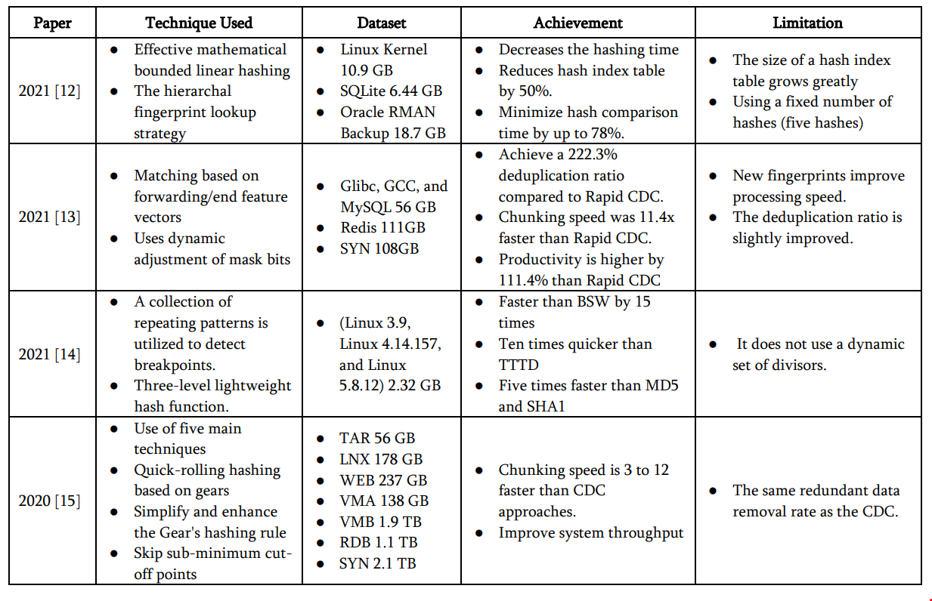

- RESULTS


The examples make it evident that deduplication works best when it is applied to data sets that change at low or moderate rates between backup events, but it can still be very beneficial for data sets with high rates of change as well.
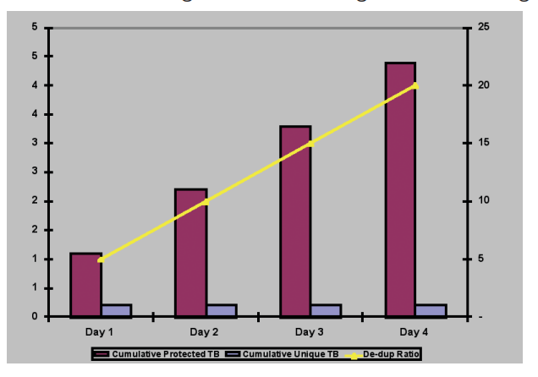

VI. CONCLUSION

Different approaches are used by numerous businesses and organizations to eliminate unnecessary data. Numerous redundant data reduction strategies are covered in this study, including the various forms of data deduplication techniques that are divided into categories such as granularity-based, time-based, side-based, and implementation, which have all been examined and explained. The salient features associated with these categories are examined. There is discussion of the difficulties and fixes for problems relating to duplicate data.
The most significant benefits and drawbacks of employing these kinds extensively are also examined and explored in this survey. The study gave advice on how to maximize the effectiveness and productivity of data deduplication in addition to providing an overview of the techniques for dividing data into fixed and variable chunks. Numerous hashing strategies have been investigated, and their main techniques have differed. MD5, SHA-1, and mathematical model-based hashing are the three main categories of hashing techniques that have been researched.
The indexes utilized to identify duplicate data chunks and save unique ones were also examined in the study. Furthermore, the various techniques and algorithms were compared based on time, efficiency, and the proportion of data that was de-duplicated.
We hope to improve a few characteristics in the future, such high performance and low computational costs.

REFERENCES

[1] Jain, A.K., Ross, A., Prabhakar, S.: ‘An introduction to biometric recognition’, IEEE Trans. Circuits Syst. Video Technol., 2004, 14, pp. 4–20

[2] Jain, A.K., Flynn, P., Ross, A.A.: ‘Handbook of biometrics’ (Springer, 2008)

[3] Jain, A.K., Nandakumar, K., Nagar, A.: ‘Biometric template security’, EURASIP J. Adv. Signal Process., 2008, 2008, pp. 1–17

[4] Cavoukian, A., Stoianov, A.: ‘Biometric encryption in encyclopedia of biometrics’ (Springer Verlag, 2009)

[5] Rathgeb, C., Uhl, A.: ‘A survey on biometric cryptosystems and cancelable biometrics’, EURASIP J. Inf. Secure., 2011, 2011, (3), doi: 10.1186/1687-417X-2011-3

[6] Uludag, U., Pankanti, S., Prabhakar, S., et al.: ‘Biometric cryptosystems: issues and challenges’, Proc. IEEE, 2004, 92, (6), pp. 948–960

[7] Ratha, N., Connell, J., Bolle, R.: ‘Enhancing security and privacy in biometrics-based authentication systems’, IBM Syst. J., 2001, 40, (3), pp. 614–634

[8] Juels, A., Rivest, and R.L.: ‘Honeywords: Making password-cracking detectable’. Proc. ACM SIGSAC Conf. on Computer and Communications Security, 2013, pp. 145–160

[9] BEAT. (2012). Biometrics Evaluation and Testing. [Online]. Available: http://www.beat-eu.org/

[10] ODNI and IARPA. (2016). IARPA-BAA-16-04 (Thor). [Online]Available:https://www.iarpa.gov/index.php/research-programs/odin/odin-baa

[11] L. Ghiani, D. A. Yambay, V. Mura, G. L. Marcialis, F. Roli, and S. A. Schuckers, “Review of the fingerprint liveness detection (LivDet) competition series: 2009 to 2015,” Image Vis. Comput., vol. 58, pp. 110–128, Feb. 2016.

[12] V. Mura et al., “LivDet 2017 fingerprint liveness detection competition,” in Proc. Int. Conf. Biometrics (ICB), Feb. 2018, pp. 297–302.

[13] J. Galbally and M. Gomez-Barrero, “Presentation attack detection in iris recognition,” in Iris and Periocular Biometrics, C. Busch and C. Rathgeb, Eds. Edison, NJ, USA: IET, Aug. 2017, pp. 235–263.

[14] E. Marasco and A. Ross, “A survey on antispoofing schemes for fingerprint recognition systems,” ACM Comput. Surv, vol. 47, no. 2, p. 28, 2015.

[15] C. Sousedik and C. Busch, “Presentation attack detection methods for fingerprint recognition systems: A survey,” IET Biometrics, vol. 3, no. 4, pp. 219–233, Dec. 2014.

[16] J. Galbally, S. Marcel, and J. Fierrez, “Biometric ant spoofing methods: A survey in face recognition,” IEEE Access, vol. 2, pp. 1530–1552, 2014.

